**Checking the code with Eclipse IDE**

1. Go to <https://github.com/haamedarshad/XACML2mCRL2>
2. Copy the Clone URL (<https://github.com/haamedarshad/XACML2mCRL2.git>)

1. Open Eclipse IDE for Java Developers (includes Incubating components)
   1. The version of my Eclipse is:
      1. Version: 2020-09 (4.17.0)
      2. Build id: 20200910-1200
2. Go to File -> Import

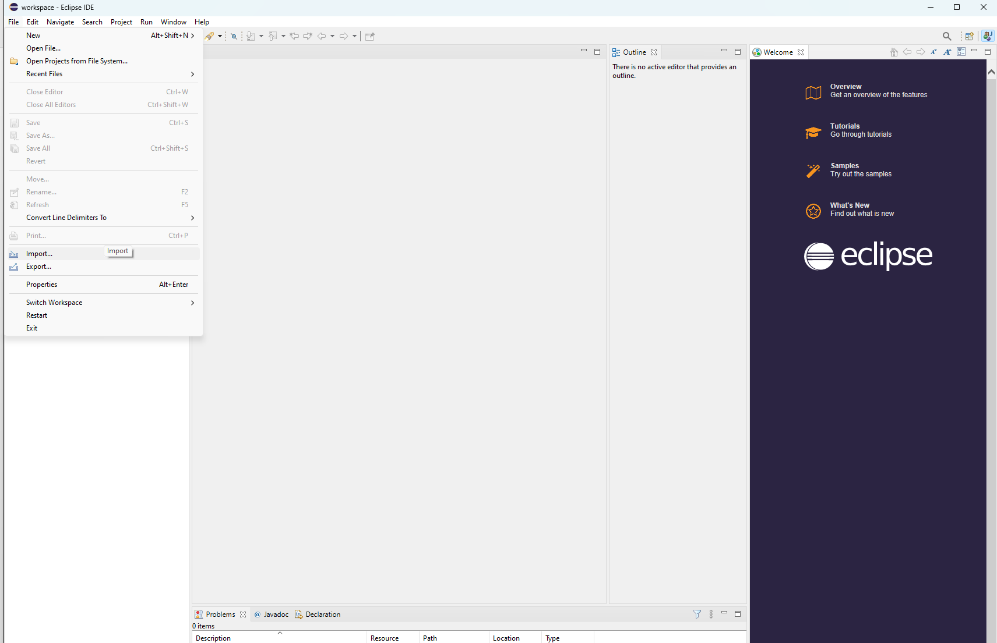

1. Git -> Projects From Git

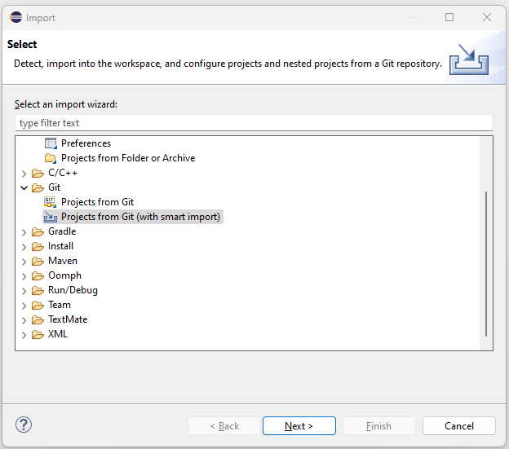

1. Clone URL

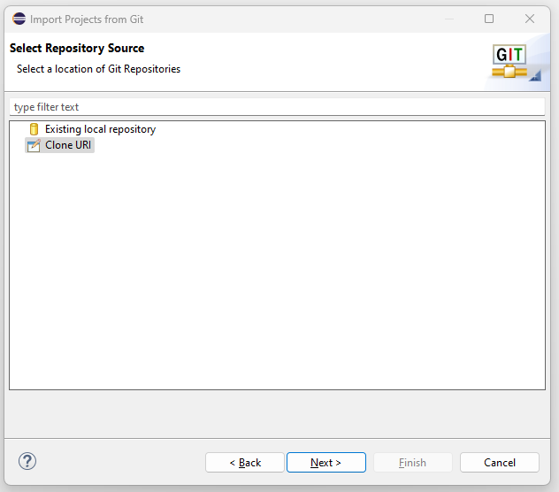

1. Specify a directory path for the project on your PC.

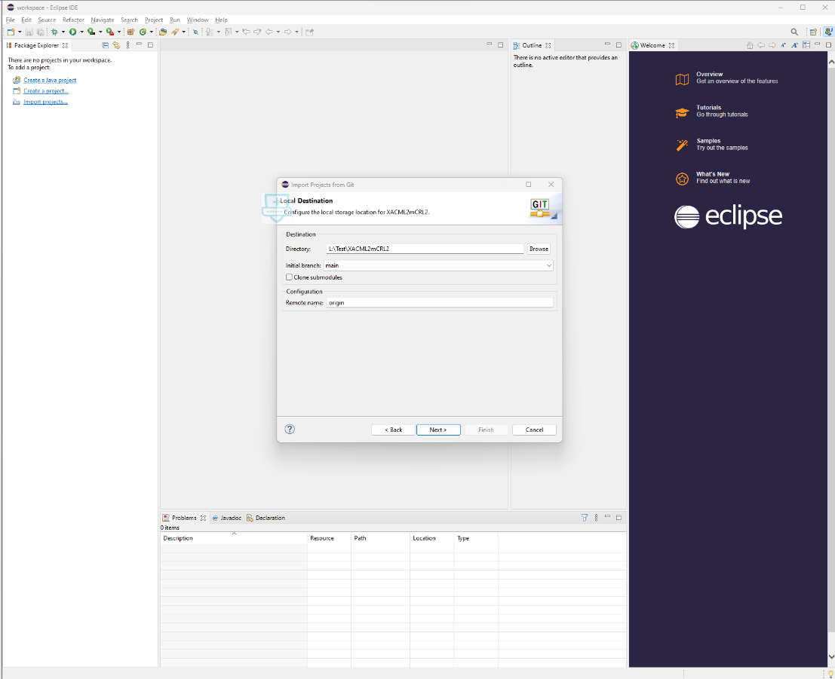

1. Check only the Eclipse project and Finish.

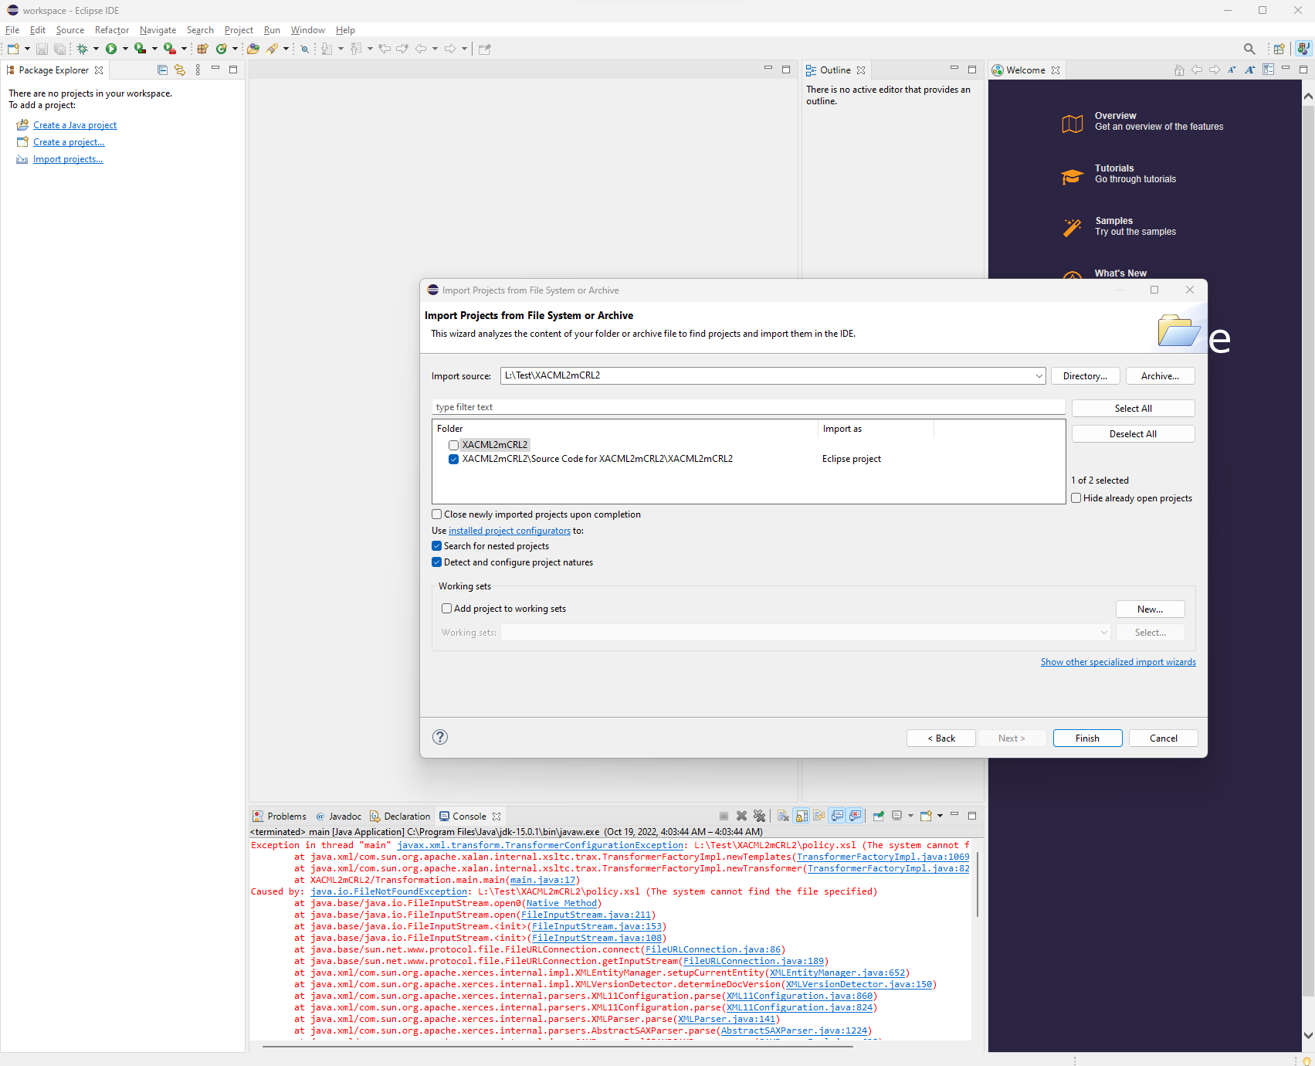

1. The project is imported

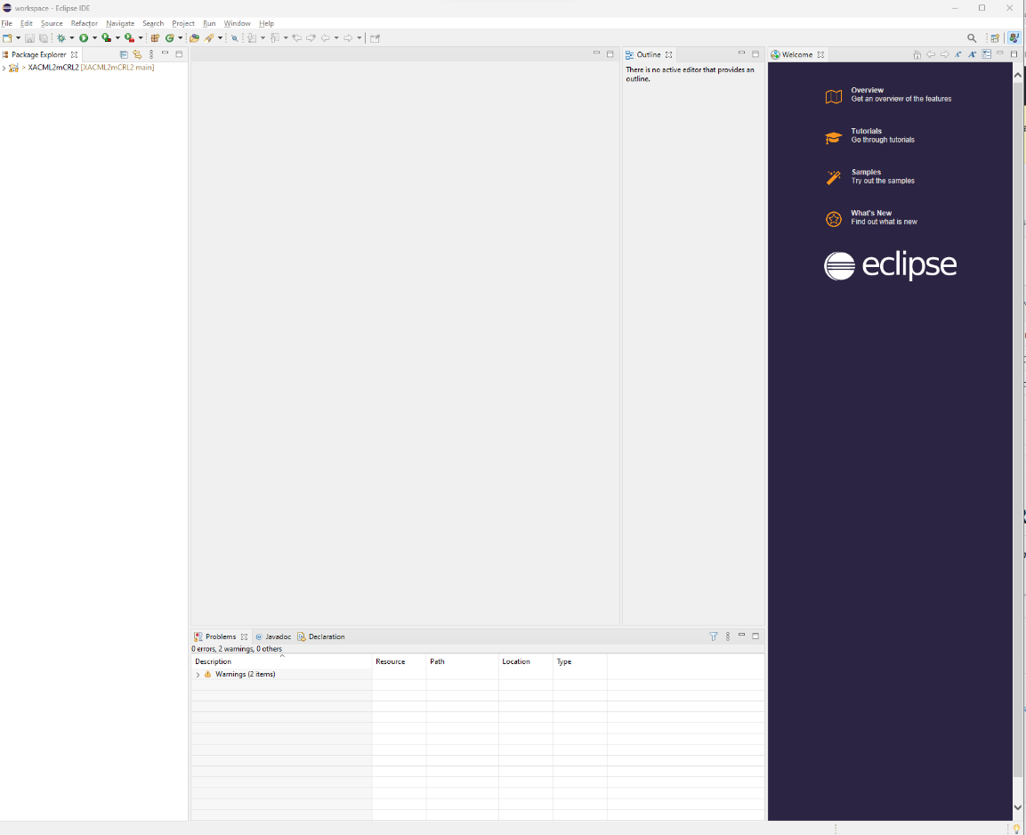

1. main.java contains the java source code. You may run the project.

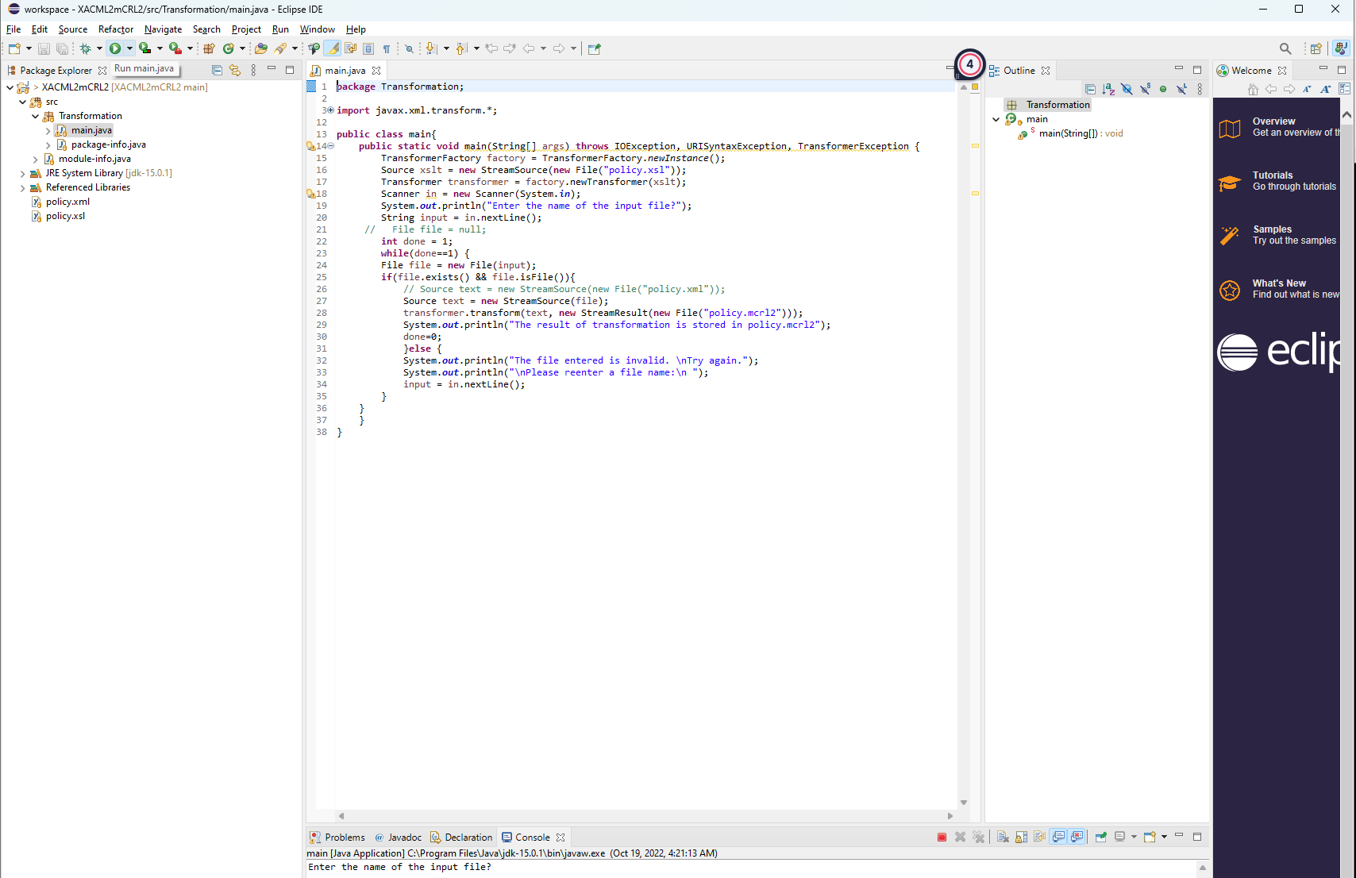

1. In the Console window (bottom) you will be asked to provide the file name. Here you have to provide the name of an xml file containing your XACML policies. This file should exist in the same folder as the source files.

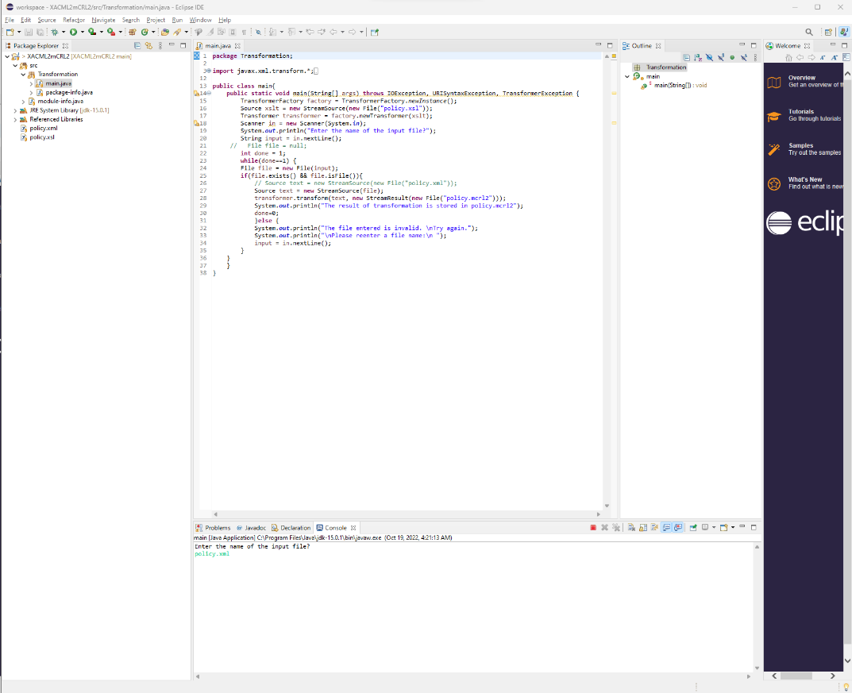

1. When you press Enter, it will create the corresponding mCRL2 file.

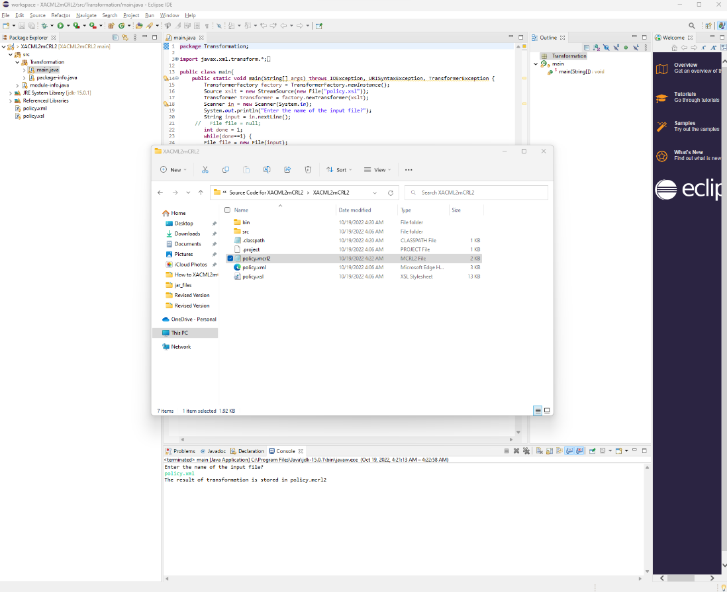

**How to RUN the executable file**

1. Download the “Executable jar file” folder from the GitHub repo.

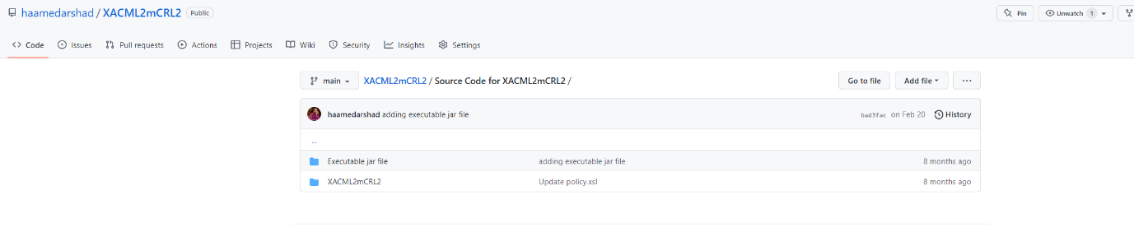

1. The downloaded folder contains “policy.xsl” and “XACML2mCRL2.jar” files.

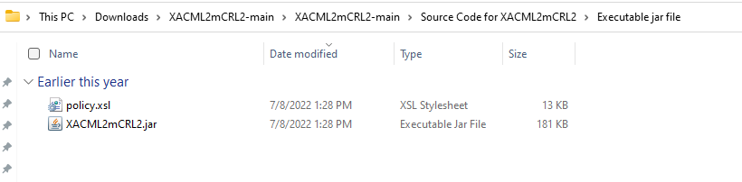

1. You may also download the “**Examples (XACML policies and corresponding mCRL2 specifications)**” from the GitHub repo (this folder contains XACML examples).

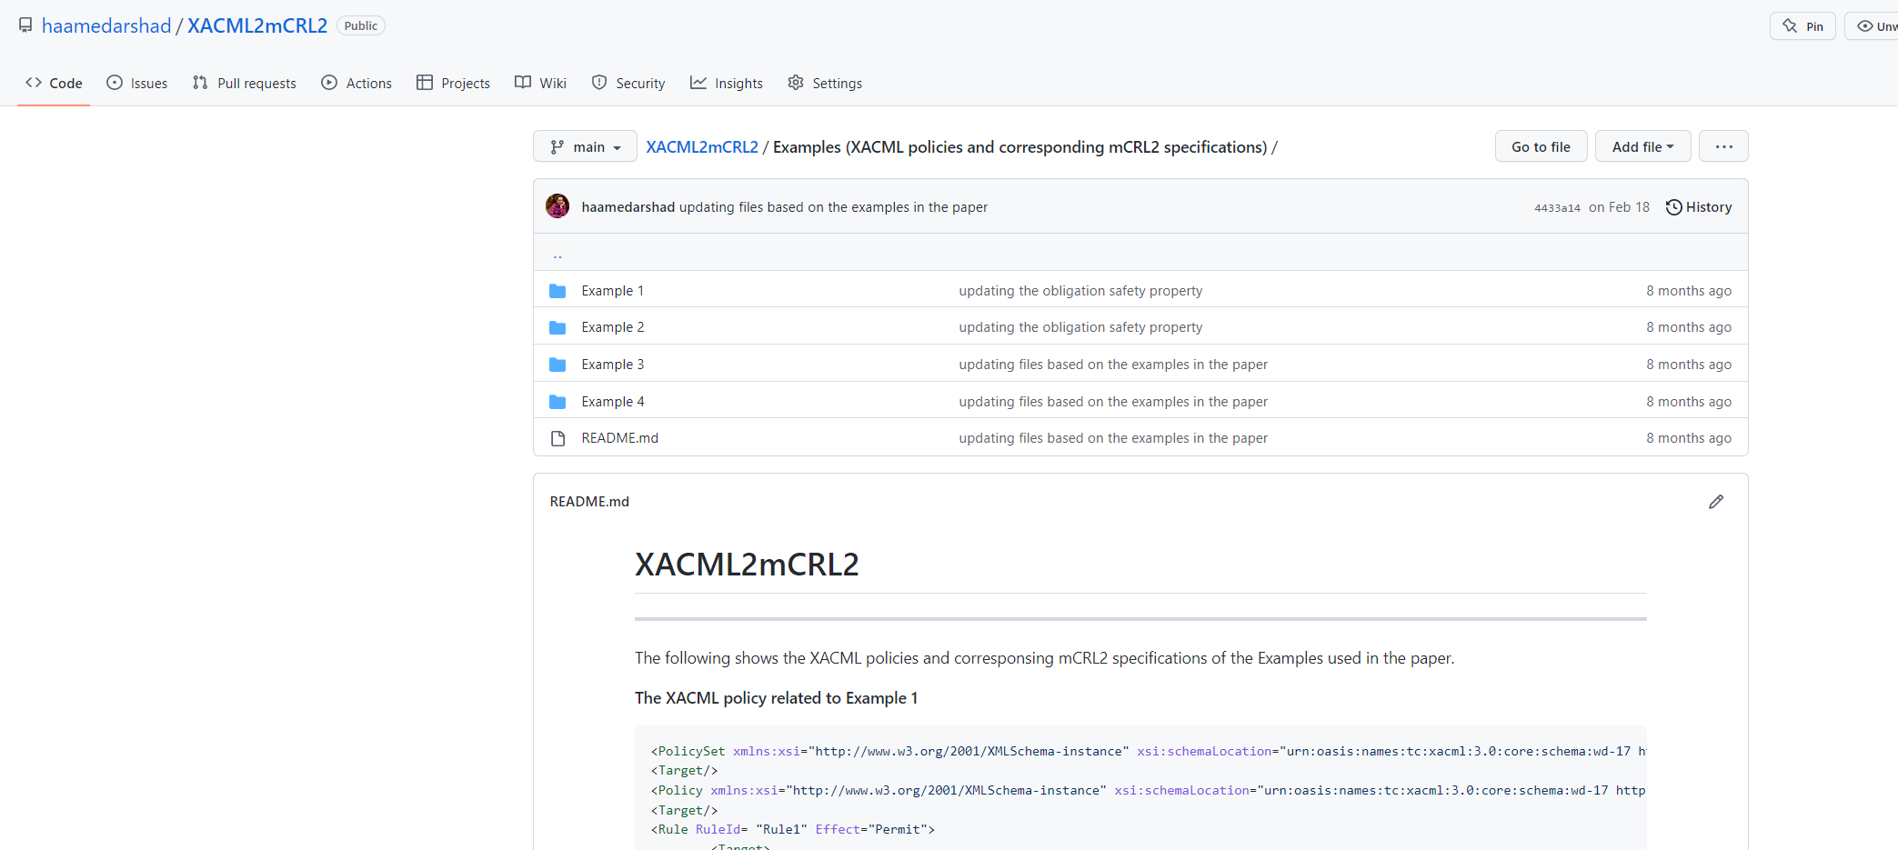

1. Move the XML files (i.e., Rule1.xml, Rule2.xml, Rule3.xml, and Rule4.xml) to the “Executable jar file” folder on your PC.

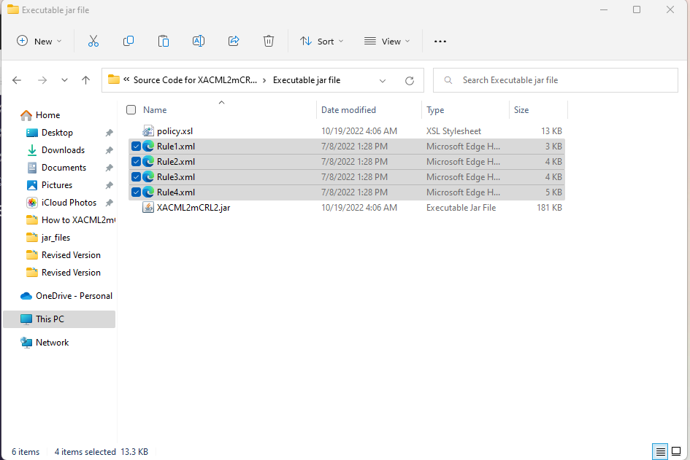

1. Open the terminal (command prompt) and go to the “Executable jar file” folder.

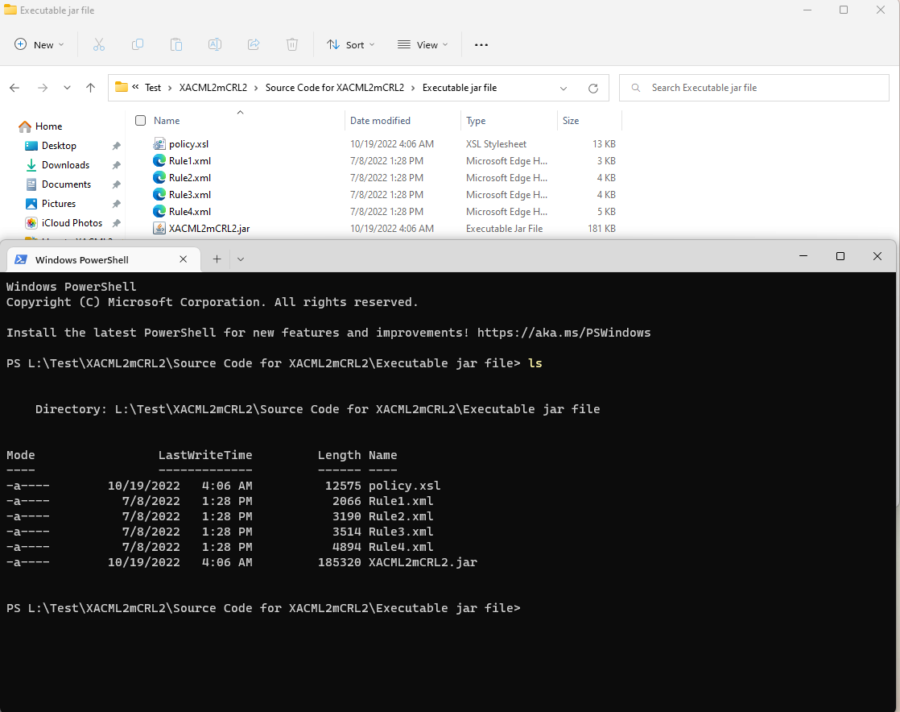

1. You may run the jar file by entering “java -jar .\XACML2mCRL2.jar”

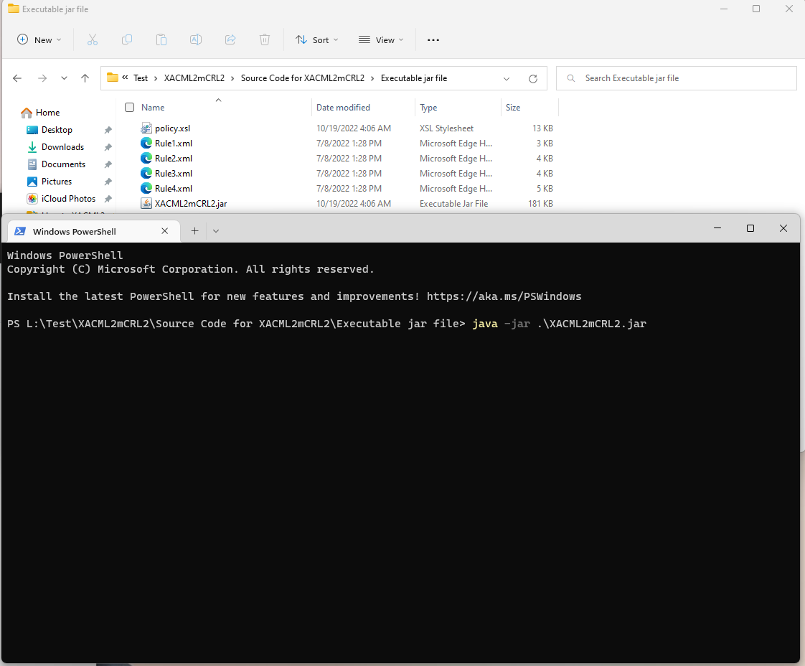

1. After pressing Enter you will be asked to provide the name of an XML file (e.g., Rule1.xml).

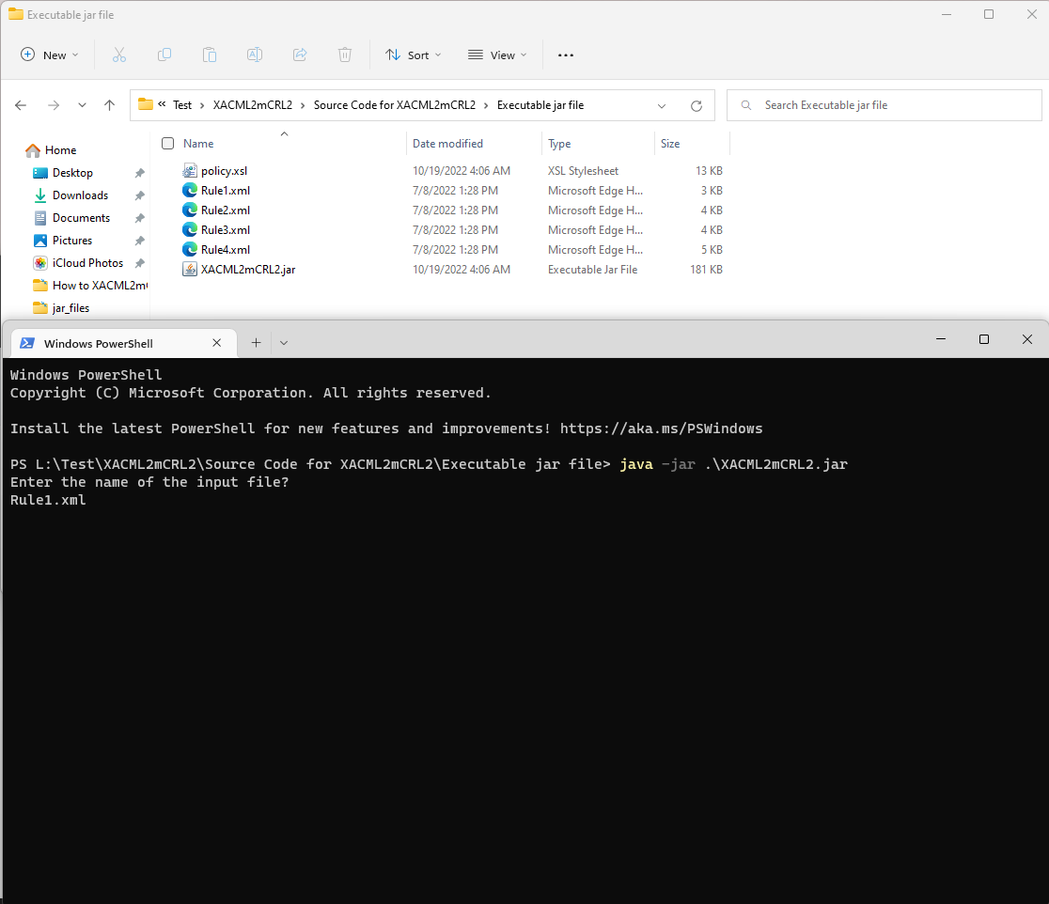

1. After pressing Enter, the result will be stored in a file named XXX.mcrl2.

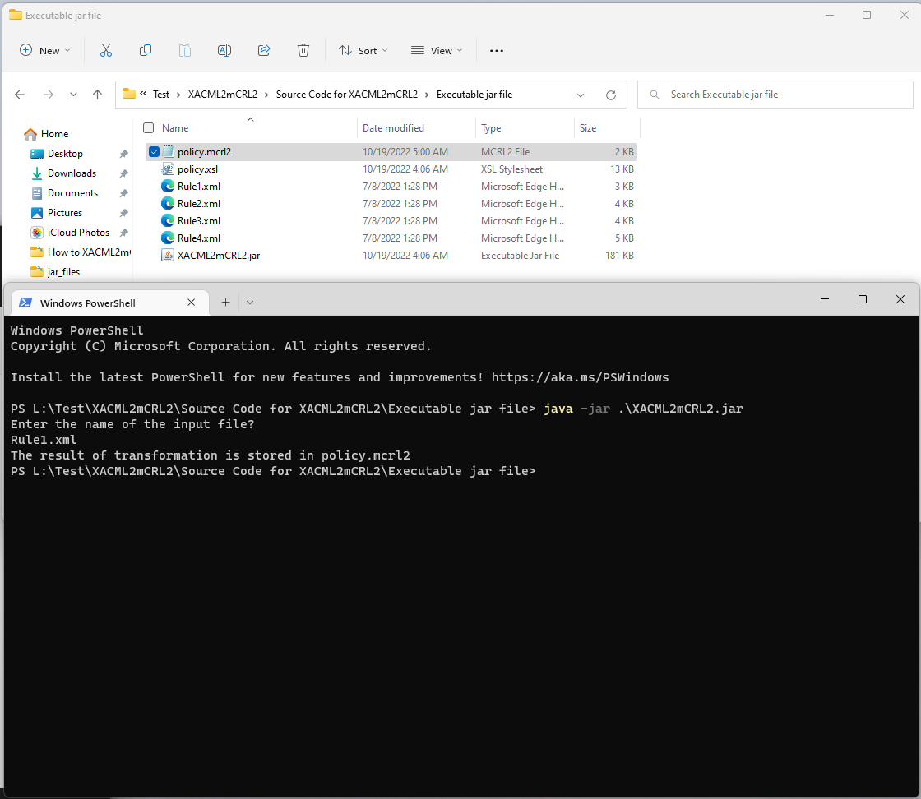

1. The generated mCRL2 specifications can be checked as explained in this video: **https://www.youtube.com/watch?v=KipRNgnkcsM&t=10s**